
EMPLOYMENT APPLICATION REVIEW SYSTEM (EARS)
D1 · Project Plan
Software Engineering — COSC 3506
Version 1.0 — Approved
Prepared by Chisom Ugochukwu & Yinka Akingbaso
Algoma University — July 29, 2026

Contents

1. Introduction 3
2. Project Organisation 4
3. Project Schedule 5
4. Resource Plan 6
5. Risk Management 7
6. Quality Assurance Plan 8

1. Introduction

1.1 Purpose
This document presents the project plan for the Employment Application Review System (EARS), a web-based platform designed to streamline the hiring process. EARS supports job posting, application submission, candidate evaluation, and interview scheduling within a single, coherent workflow.

1.2 Scope
EARS serves three user roles — Applicant, Reviewer, and Administrator — and covers the complete hiring workflow from the creation of a job posting through to final candidate selection.

1.3 Objectives
- Reduce manual processing time for job applications by 60%.
- Provide secure, role-based access to sensitive candidate data.
- Enable standardized candidate evaluation using a four-criteria rubric.
- Automate interview scheduling and the associated notifications.

2. Project Organisation

2.1 Team Structure
Team Member | Student ID | Responsibilities
Chisom Ugochukwu | 5148780 | Frontend development, UI/UX design, QA management, documentation
Yinka Akingbaso | 5142977 | Backend development, database design, authentication, API development

2.2 Communication Plan
Channel | Purpose
Daily stand-up (15 min, Discord) | Progress sync and blocker removal
Weekly review (Fridays) | Milestone and progress assessment
Google Drive | Document sharing and version history
GitHub | Code collaboration and pull-request reviews
Jira | Backlog management, sprint planning, and burndown tracking

3. Project Schedule
The project is executed as a one-week sprint, from July 29 to August 4, 2026. Figure 1 shows the planned allocation of deliverables across the sprint, including ownership by team member.
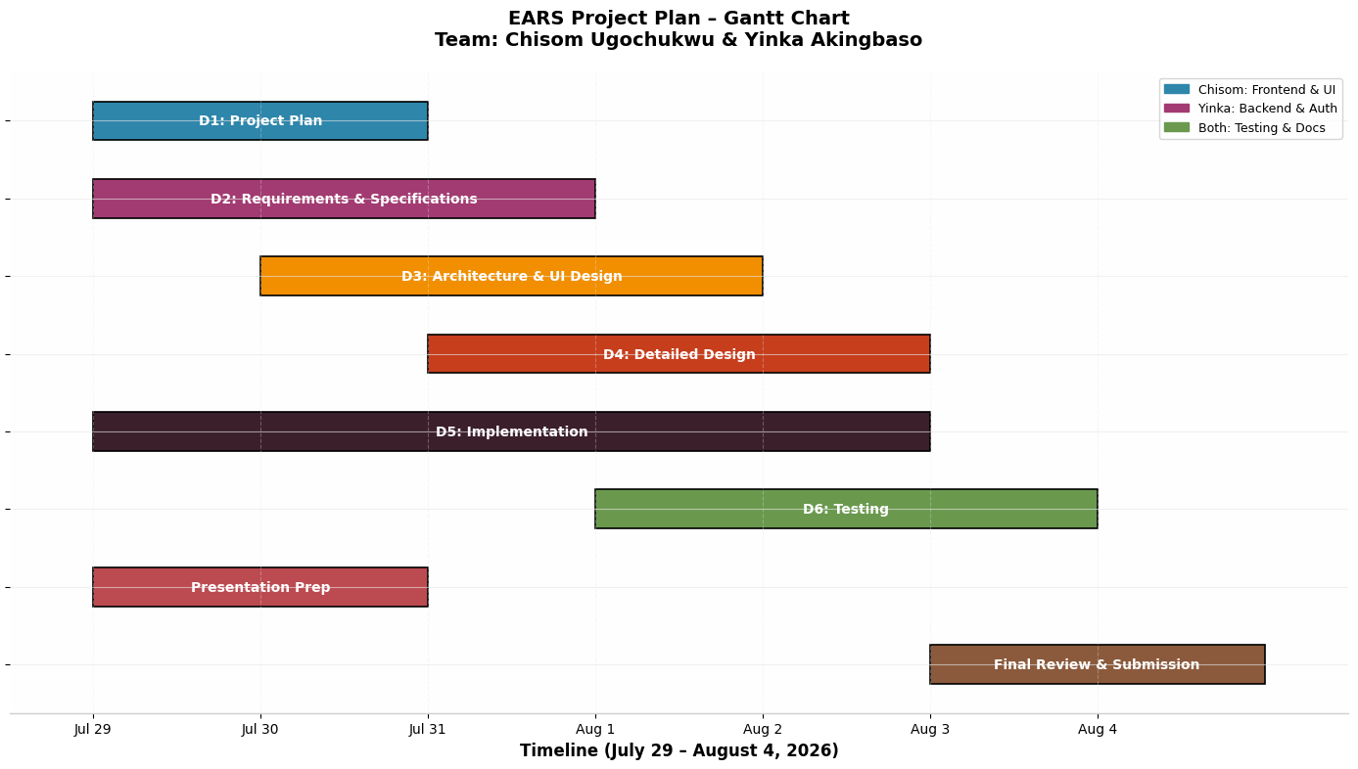
Figure 1: EARS project plan — Gantt chart (July 29 – August 4, 2026)
Five milestones anchor the schedule:
Milestone | Date | Deliverable
M1 | Jul 29 | Requirements finalized and architecture approved
M2 | Jul 30 | Presentation and mid-evaluation completed
M3 | Aug 2 | Core implementation complete (authentication, jobs, applications)
M4 | Aug 3 | Testing and bug fixes complete
M5 | Aug 4 | Final submission

4. Resource Plan

4.1 Hardware
- MacBook Pro (Chisom) — development, testing, and presentation.
- Windows laptop (Yinka) — backend development and database testing.

4.2 Software
Tool | Purpose
Visual Studio Code | Integrated development environment
Node.js v18+ | Server-side runtime
SQLite3 | Embedded relational database
Chrome DevTools | Frontend debugging and responsive testing
draw.io | UML diagram production
Jira | Project management and sprint tracking

5. Risk Management
Eight risks were assessed for probability and impact (Figure 2). Each risk carries a named mitigation strategy, reviewed at every weekly progress meeting.
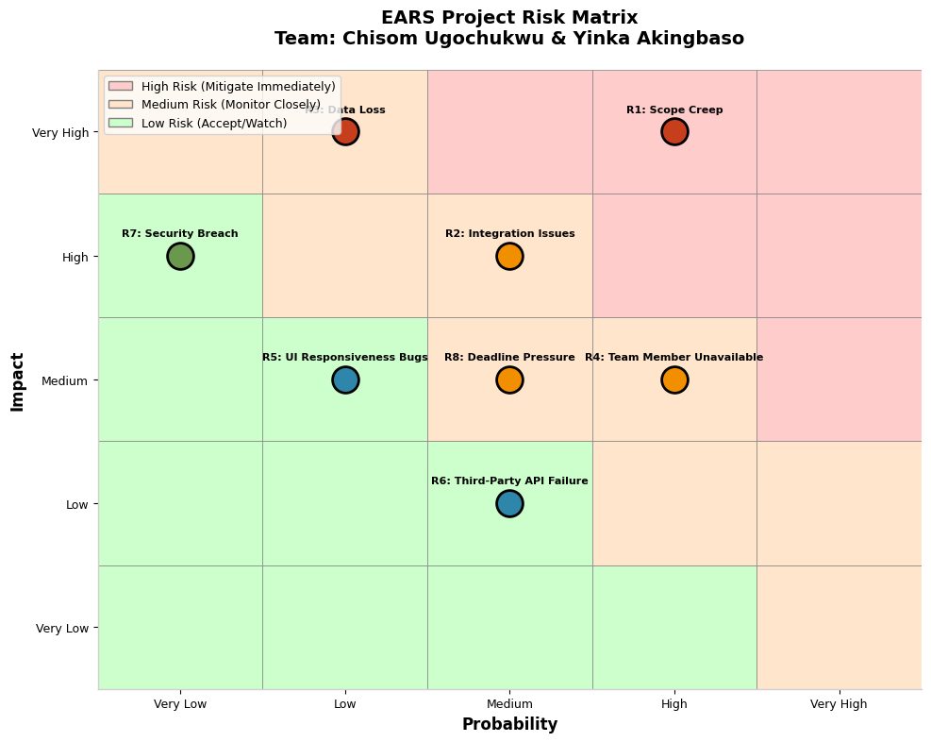
Figure 2: EARS project risk matrix (probability × impact)
ID | Risk | Mitigation Strategy
R1 | Scope creep | Strict change-control process; weekly scope reviews
R2 | Integration issues | Daily integration testing; API documentation maintained
R3 | Data loss | Automated SQLite backups; version control via Git
R4 | Team member unavailable | Cross-training on critical components; shared documentation
R5 | UI responsiveness bugs | Responsive design framework; multi-device testing
R6 | Third-party API failure | Graceful error handling; fallback UI states
R7 | Security breach | bcrypt password hashing; 30-minute session timeout; input validation
R8 | Deadline pressure | Buffer time built into the schedule; priority-based task management

6. Quality Assurance Plan
- Code reviews are mandatory for all pull requests before merging.
- Unit testing covers all backend API endpoints.
- Integration testing verifies frontend–backend communication.
- User acceptance testing is performed with dedicated demo accounts.
- Security testing targets authentication flows and role boundaries.

